0 Level DFD – Student Management System
The 0 level dfd known as context level data flow diagram. The context level data flow diagram (dfd) is describe the whole system. The (o) level dfd describe the all user modules who run the system. Below context level data flow diagram of Student management system project shows the one Admin user can operate the system. Admin do all activities after login to system.
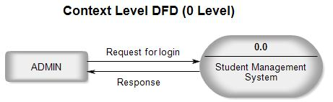0 Level DFD for student management system project

1st level DFD – Student Management System
The Admin side DFD describe the functionality of Admin. Admin is a responsible person who run the project. After login to system admin can first Add Course Detail and Teacher Detail and then add student detail by course wise. and admin can manage student reports and fees payment detail.
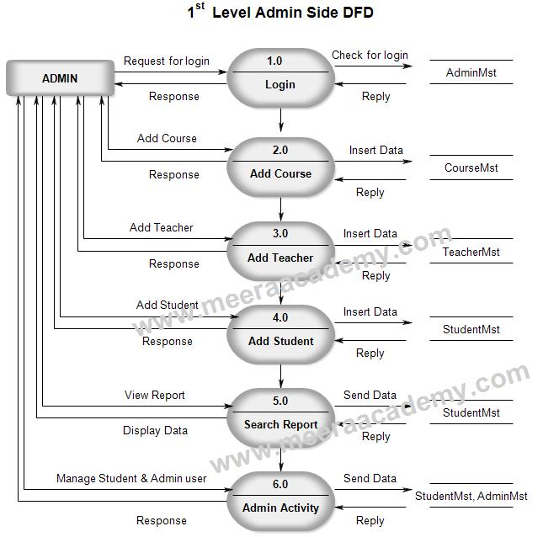1 Level DFD for student management system project.

2nd Level DFD – Level 4.0
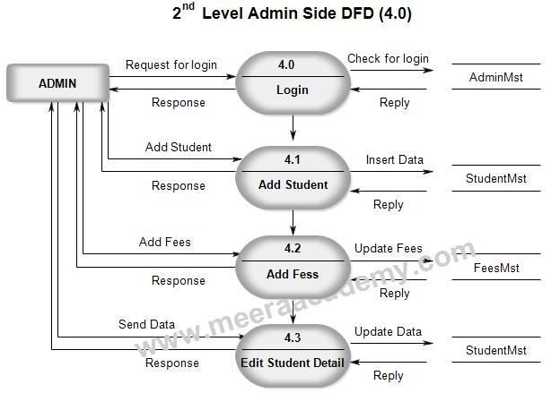2 Level DFD- 4.0 for student management system project.

2nd Level DFD – Level 6.0
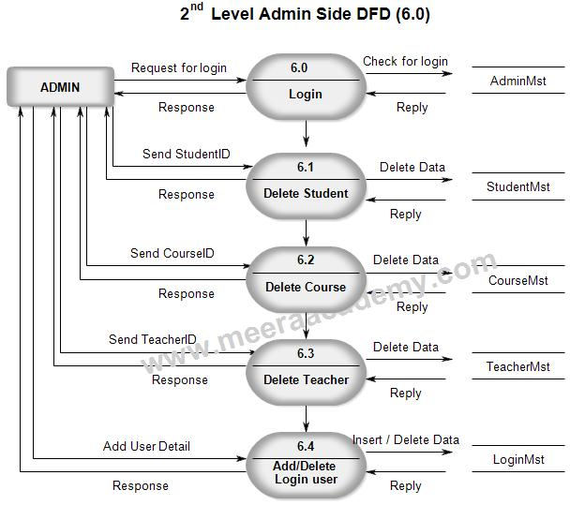2 Level DFD- 6.0 for student management system project.

Context level DFD – 0 level
The context level data flow diagram (dfd) is describe the whole system. It shows the all user module who operate the system. The Hospital management system data flow diagram shows there is only one user hospital admin staff to run the system.
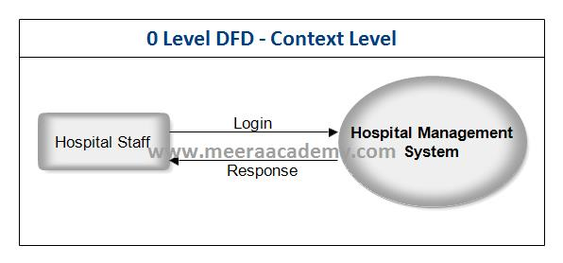DFD 0 Level – Hospital Management System

1st Level DFD – Hospital Management System
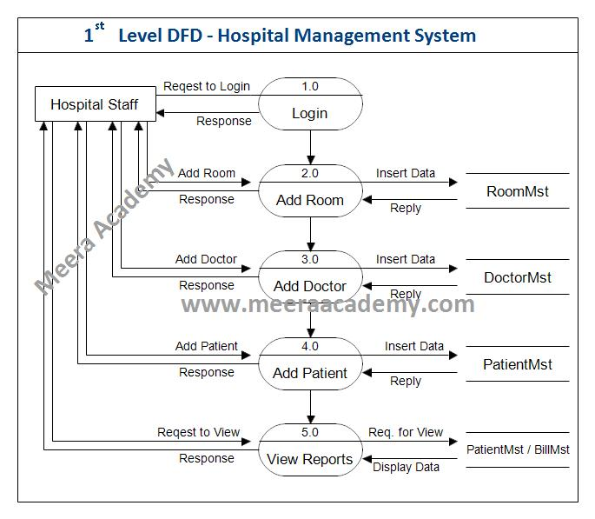DFD 1 Level – Hospital Management System

2nd Level DFD (2.0) – Hospital management System
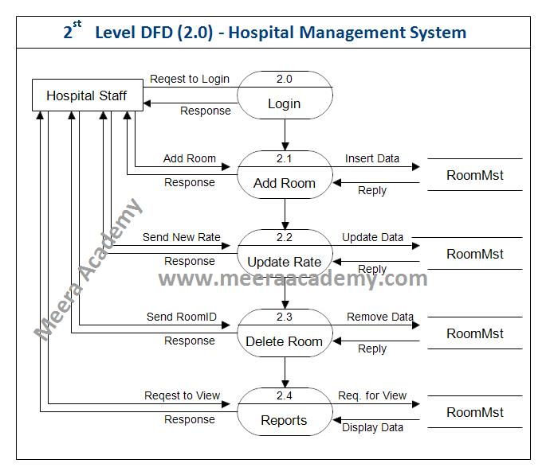DFD 2nd Level (2.0) – Hospital Management System

2nd Level DFD (3.0) – Hospital management System
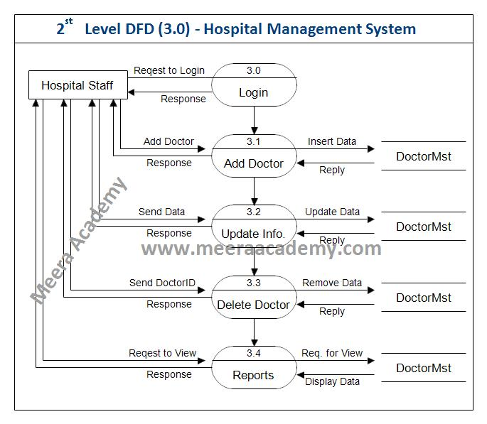DFD 2nd Level (3.0)- Hospital Management System C#.Net Project

2nd Level DFD (4.0) – Hospital management System
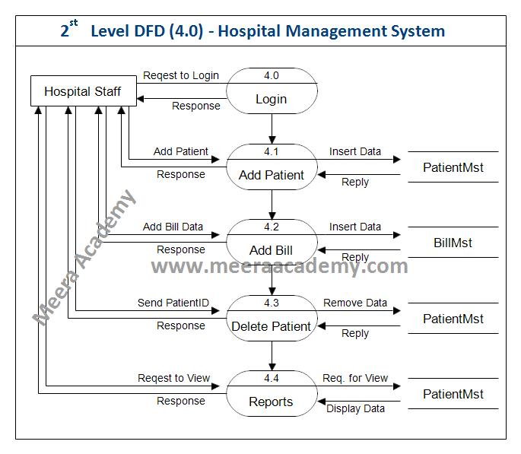DFD 2nd Level (4.0) – Hospital Management System

2nd Level DFD (5.0) – Hospital management System
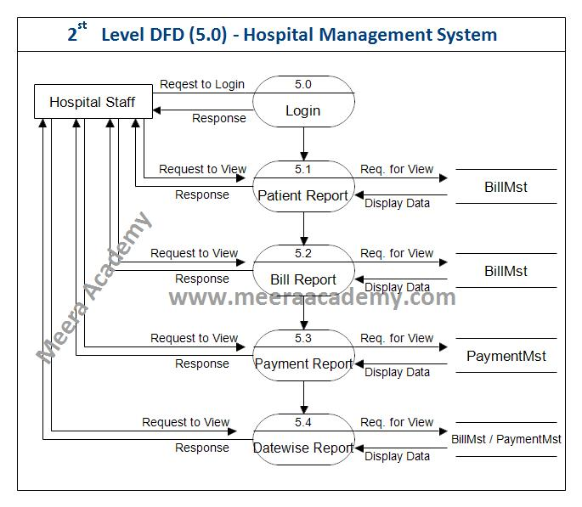DFD 2nd Level (5.0) – Hospital Management System

3rd Level DFD (4.2) – Hospital management System
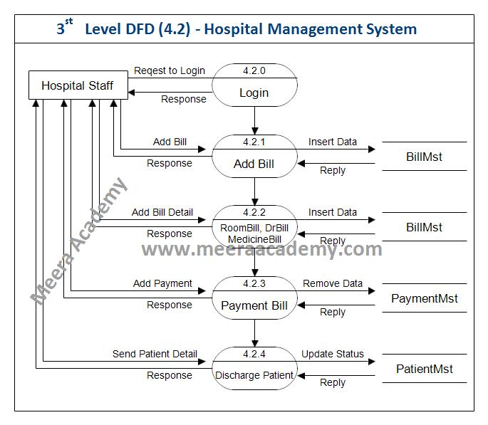DFD 3rd Level (4.2) – Hospital Management System

Data Flow Diagram for Online Teaching Project
A data flow diagram is a graphical view of how data is processed in a system in terms of input and output.
The Data flow diagram (DFD) contains some symbol for drawing the data flow diagram.

Context Level Diagram (0 level DFD)
The context level data flow diagram (dfd) is describe the whole system. The (o) level DFD describe all user module who operate the system. Below data flow diagram of online teaching website shows the three user can operate the system Admin, Teacher and Student.
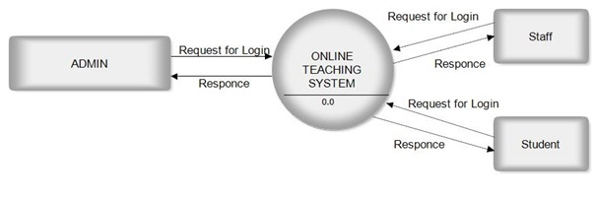DFD for Online Teaching Project

Admin Side DFD
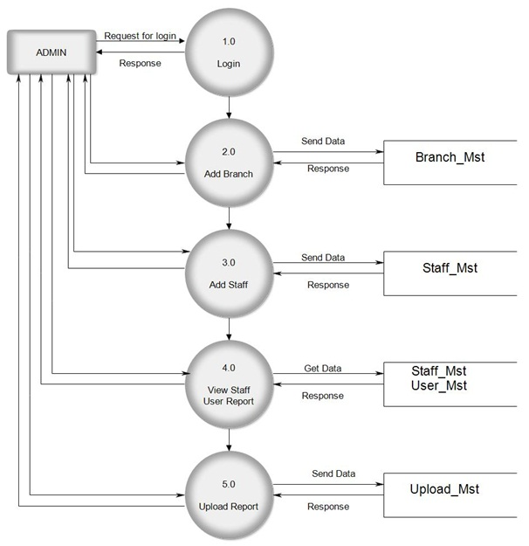Admin Side DFD for Online Teaching Project

Teacher Side DFD
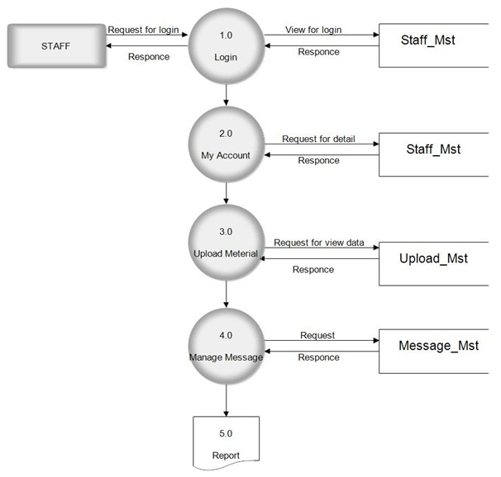Teacher Side DFD for Online Teaching Project

Student Side DFD
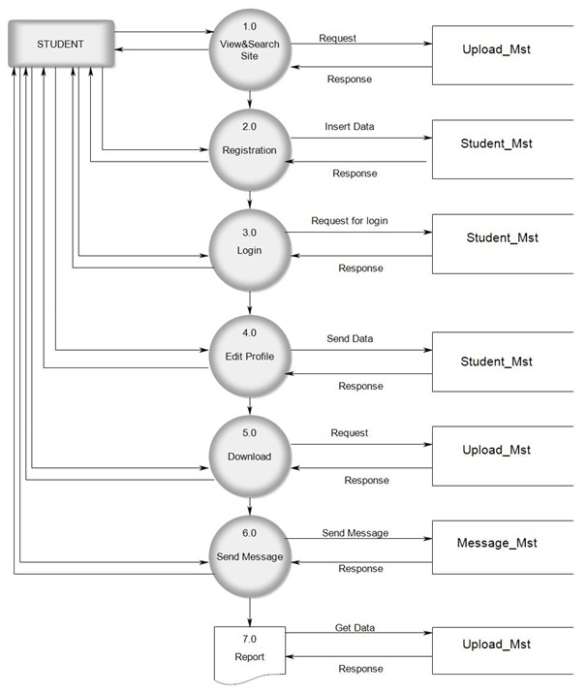Student Side DFD for Online Teaching Project

